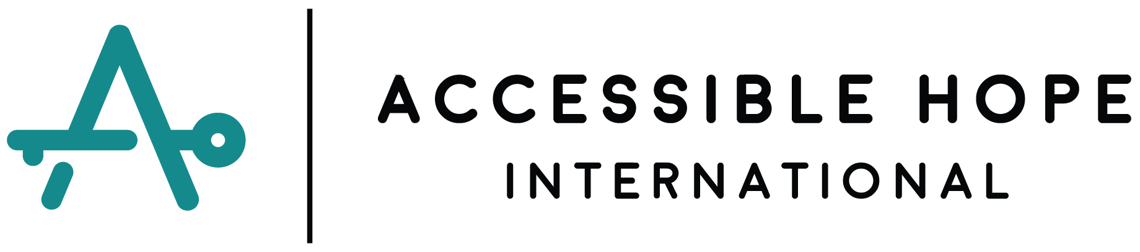
Equip Training of Trainers (TOT) Request Form
This form is to request a Training of Trainers (TOT) workshop for the Theology of Disability (ToD) curriculum with Accessible Hope International (AHI). Please answer ALL questions in every section, typing your answers directly into the grey boxes provided. Once you have completed your answers, save the form, and email the completed TOT Request Form to the following email address: equip@ahint.org

Section 1 of 4
Personal Information
Full Name:
Email Address:
Today’s Date:
Your City & Country of Residence:
Primary Language YOU speak:
Additional Languages YOU speak:
Have you participated in any AHI workshops or used any of AHI’s resources?
(Mark an X next to ANY that apply.)
- Virtual Made in God’s Image workshop
- Virtual Theology of Disability Workshop
- In-Person Theology of Disability (1-2 day) Workshop
- In-Person Training of Trainers (4-day) Workshop
- In His Image WhatsApp Resource (10 weeks of video teaching)
- Church Resource Tool
- MiGI Resource Curriculum
Please describe any previous connection you have with Accessible Hope International.

Section 2 of 4
Organization/Ministry Information
Please provide the following information for the organization or ministry that will host the TOT.
Organization or Ministry Name:
Ministry/Organization FULL Physical Address:

Country or Countries of Operation:
Primary Contact’s Name:
Primary Contact’s Email Address:
Primary Contact’s WhatsApp Number:
List all common languages spoken by the people in your ministry/organization.
For example: English, French, Spanish, Portuguese, Swahili, Hindi, etc.

Mark with an X the size of the area your ministry/organization serves.
- Multi-national (serves in more than one country)
- National (serves an entire country)
- Regional (serves one or more regions within your country)
- District/Village level (serves one specific area or city in your country)
Is your ministry specifically faith-based?
(Mark the answer with an X.)
Yes
No
Would you describe your ministry as an evangelical Christian organization?
Yes
No
Are you affiliated with any specific church or denomination? If so, which one?

How many paid employees work for your ministry/organization?

How many unpaid volunteers serve with your ministry/organization?

What year was your ministry/organization started?

Describe the population that your ministry/organization serves.
(Please provide information like–the number of program participants, characteristics, and any specific limitations to service provision–such as only women, only children, only widows, etc.)

Do you specifically serve people with disabilities?
(Mark your answer with an X.)
Yes
No
If yes, what is the approximate number of PWDs (people with disabilities) participating in your program services?

What are the primary types of disabilities that you see in your area?

Describe the general beliefs about or attitudes toward disability in your region/country/culture.

What are the primary activities or programs your ministry/organization carries out among persons with disabilities?

Section 3 of 4
TOT Hosting Requirements and Responsibilities
The following section describes the requirements and responsibilities of an organization to host a TOT. Please read the information carefully and honestly answer any questions.
The Host/s of the TOT are responsible for ALL in-country logistics, planning, communication, and financial costs for the workshop.
Financial Costs and Responsibilities:
AHI will provide:
- Transportation of two Training Ambassadors to the airport nearest the city in which the training will be held
- Training manuals for each participant in the workshop
- Church Resource Tools for each participant
- All needed training materials (except the easel and flipchart paper)

Host Ministry will provide:
- Clean and safe accommodations for two facilitators (separate rooms for different genders or separate beds for Training Ambassadors of the same gender).
  - This can be in a hotel, motel, Airbnb, guesthouse, or other rented accommodation space.
  - This could be with a host family.
  - This could be at a local monastery or retreat center.
- Transportation of the facilitators from the nearest international or regional airport.
- Transportation for the facilitators to and from the workshop site each day.
- Food provision for two facilitators for 6 full days—4 training days and one day on either side of the training for preparation and follow-up activities.
- Food for the workshop participants throughout the four-day workshop.
- Venue-related costs—rental of space, chair/table rental, sound system (if needed), etc.
  - AHI recommends partnering with local churches for free or low-cost venue space.
- Training materials—flipchart paper, flipchart easel, etc.

To enable TOT Hosts to bear the financial cost of hosting a TOT and multiply the impact of any training workshop, AHI requires that several organizations or ministries come together to host collaboratively. It is our desire that this training impacts as many communities as possible, multiplying the benefit among people with disabilities in that area.

Please give the names and email addresses of AT LEAST TWO or THREE other organizations/ministries whom you HAVE already contacted and who have communicated they are willing to collaborate with you in hosting this Training of Trainers workshop event.

Organization #1 Name:
Organization #2 Name:
Organization #3 Name:

I have READ and I UNDERSTAND the hosting requirements and responsibilities. I am fully prepared to collaborate with other local organizations/ministries so that together we can host a TOT. By typing my name in the box below, I commit to these requirements and responsibilities.

Section 4 of 4
Additional Training Information
A Training of Trainers for a ToD enables participants of the workshop to be equipped to facilitate ToDs in their local context. These workshops help ministry and church leaders learn to think Biblically about disability and develop more effective plans to reach people with disabilities with a wholistic Gospel.

Please tell us how a TOT will benefit your organization and your community.

When could your organization be ready to host a TOT?
(Mark your answer with an X.)
- We could be prepared to host in 9 months.
- We could be prepared to host in 12 months.
- We could be prepared to host in 18 months.
A TOT must have at least 20 participants, and no more than 30, participants.
Will you be able to gather the right number of people for your TOT?

What is the primary language spoken by those who will participate in the TOT?

How many participants speak English fluently?
Enter the number of fluent English speakers here.

Once completed, please save this form with the following name “Equip TOT Request—name of organization.docx” and email the completed TOT Request Form to the following email address: equip@ahint.org

